**Technical Design Document (TDD)**

**Title: Demographic Analysis on Indian Census**

**Table of Contents**

[***1.*** ***Introduction 3***](https://docs.google.com/document/d/1fZoclVBu5oNIr_hctlG0mSjTqYf5J4RG/edit#heading=h.gjdgxs)

[**1.1 Purpose**](https://docs.google.com/document/d/1fZoclVBu5oNIr_hctlG0mSjTqYf5J4RG/edit#heading=h.30j0zll) [**3**](https://docs.google.com/document/d/1fZoclVBu5oNIr_hctlG0mSjTqYf5J4RG/edit#heading=h.30j0zll)

[**1.2** **Scope**](https://docs.google.com/document/d/1fZoclVBu5oNIr_hctlG0mSjTqYf5J4RG/edit#heading=h.1fob9te)  **3**

**1.3 Objective 3**

[**1.4 Document Organization**](https://docs.google.com/document/d/1fZoclVBu5oNIr_hctlG0mSjTqYf5J4RG/edit#heading=h.3znysh7)  **4**

**1.5** **Audience 4**

[***2.*** ***System Overview 4***](https://docs.google.com/document/d/1fZoclVBu5oNIr_hctlG0mSjTqYf5J4RG/edit#heading=h.tyjcwt)

[**2.1 Context**](https://docs.google.com/document/d/1fZoclVBu5oNIr_hctlG0mSjTqYf5J4RG/edit#heading=h.3dy6vkm)  **4**

[**2.2 Product Feature**](https://docs.google.com/document/d/1fZoclVBu5oNIr_hctlG0mSjTqYf5J4RG/edit#heading=h.1t3h5sf)  **5**

**2.3 Data Required 5**

[***3*** ***Architecture Design***](https://docs.google.com/document/d/1fZoclVBu5oNIr_hctlG0mSjTqYf5J4RG/edit#heading=h.2s8eyo1) ***5***

[***4*** ***Project Architecture***](https://docs.google.com/document/d/1fZoclVBu5oNIr_hctlG0mSjTqYf5J4RG/edit#heading=h.2s8eyo1) ***5***

[***5*** ***Data Visualization***](https://docs.google.com/document/d/1fZoclVBu5oNIr_hctlG0mSjTqYf5J4RG/edit#heading=h.2s8eyo1) ***6 - 7***

**Revision History**

|  |  |  |
| --- | --- | --- |
| **Version** | Date | Description |
| *1.0* | 12/07/2022 | Initial Draft |
| *2.0* | 22/07/2022 | Final Draft |

**1. Introduction**

**1.1 Purpose**:

Censuses provide the principal measure of population size for countries and geographic subdivisions within countries while also providing detailed information on the demographic, social, and economic characteristics of the population.

It is important to note that the main goal of needs Census analysis is to identify he information of a given population is calculated on basis of economical, educational and social records, in a given period of time that affect area, density of population and sex ratio provide the appropriate detailed Visualization.

Visualization lets you comprehend vast amounts of data at a glance and in a better way. It helps to understand the data better to measure its impact on the census and communicates the insight visually.

**1.2 Scope**:

Demographic analysis is an important tool for evaluating census data, particularly in countries where independent sources of data, such as vital registration and sample surveys, are lacking or where a post-enumeration survey (PES) is not conducted. A weakness with demographic analysis is that it generally does not provide enough information

These are many advantages of Demographic analysis, few namely:

1. With demographic segmentation, organizations are better informed to create personalized marketing strategies that appeal to specific consumer preferences.
2. Demography is useful for governments and private businesses as a means of analyzing and predicting social, cultural, and economic trends related to population.

**1.3 Objective**:

To get detailed outcomes by analysis of census data and focus on area where improvement required.

**1.4 Document organization:**

|  |  |
| --- | --- |
| Introduction | Provides information related to document |
| Application Architecture | Describes the project architecture and flow diagram is of project |
| Assumptions and constraints | Details of various assumptions made during design and visualize of BI tool |

**1.5 Audience:**

The intended audiences for this document are:

* Github
* All Public

**2. System Overview**

**2.1 Context**:

Demographic Analysis (DA) is a method used to evaluate the quality of the census. We use current and historical vital records, data on international migration, and Medicare records to produce national estimates of the population on April 1 by age, sex, the DA race categories, and Hispanic origin. The DA population estimates are independent of the decennial census. The results are used to produce estimates of net coverage error, which are calculated as the percent difference between the census counts and the DA population estimates.

Traditionally, the DA estimates have been produced by sex and single year of age for the race categories Black and non-Black. Starting in 2010, the DA program produces estimates by Hispanic origin (Hispanic/Non-Hispanic) for a limited number of ages. New data sources, changes in the racial and ethnic make-up of the nation, and evolving patterns of international migration present both challenges and opportunities for DA.

**2.2 Product Feature**:

**Demographic Analysis**:

Demography uses databases of public statistics, including Population, Growth Rate, Sex Ratio, Literacy Rate, Area Km2 as well as data from censuses.

**2.3 Data Requirement**:

There will be an Excel file with extracted census data from sites mention below

<https://www.census2011.co.in/district.php>

## **3. Architecture Design**

1. We have extracted dataset in excel format, just import the datasets into Microsoft SQL Server Management Studio.

2. Datasets are imported now need to analyze dataset and extract insights from the datasets and store it in the tables.

3. Connect the BI tool with SQL server and Visualize the insight tables into appropriate charts.

## **4. Project Architecture**

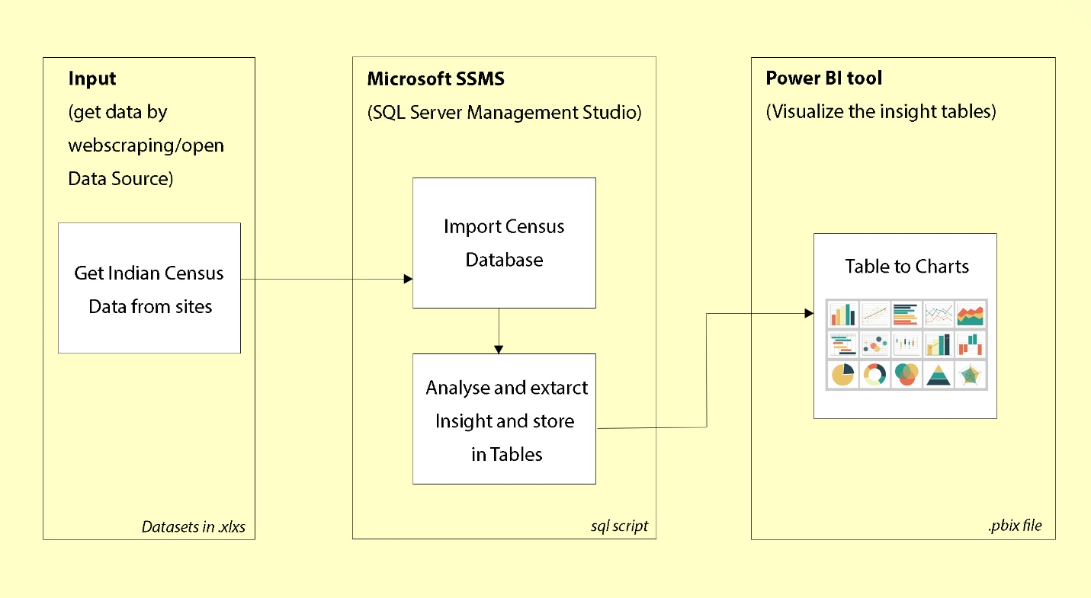

## **5. Data Visualization**

**1. Interactive Dashboard**

In dashboard we can se the Avg Sex ratio, No. of female and males in gauge and donut diagram as well as in number format.

Visualization of population per state can be shown in map in circular format, more the population will represent by larger circle.

Interactive table in dashboard population and sexratio for states, we can sort by each column or field.

Graph of top 5 District with highest sex ratio also present in dashboard.

In corner slicer added for visualize whole dashboard items for particular state and district.

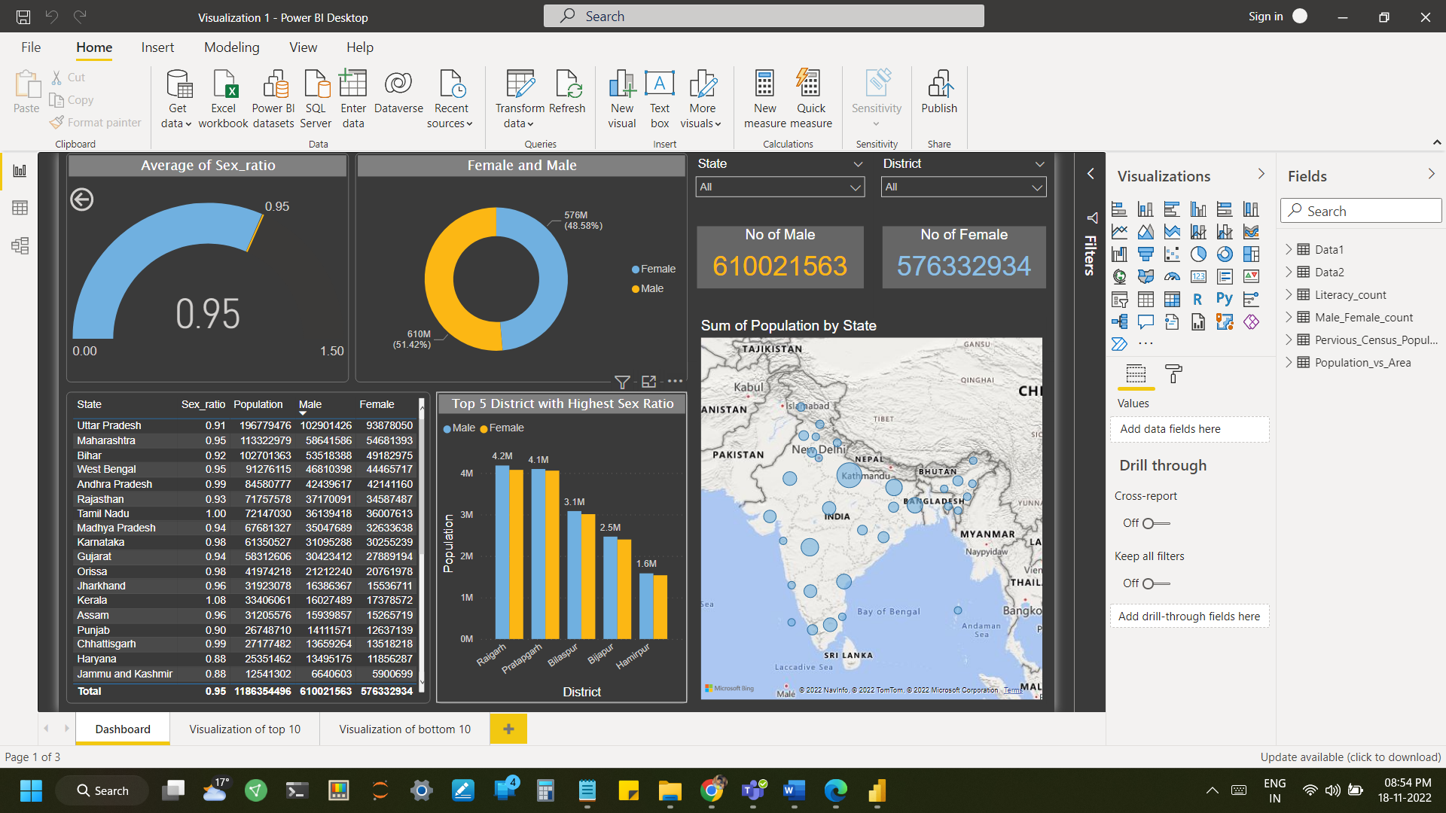

**2. Sheet to Visualize of top and bottom 10 by:**

2.1. Highest Growth Rate

2.2. Highest Sex Ratio

2.3. Highest Literacy

2.4. Populated State

